Phonics Resources and Support for parents
https://home.oxfordowl.co.uk/reading/learn-to-read-phonics/
Learn to read with phonics: a parent guide (including how to say the sounds, blending, all the Set 1, Set 2 & Set 3 sound sheets and information about the Phonics Screening check with links to past papers).
https://www.ruthmiskin.com/en/
Ruth Miskin website
Three short video clips to support parents
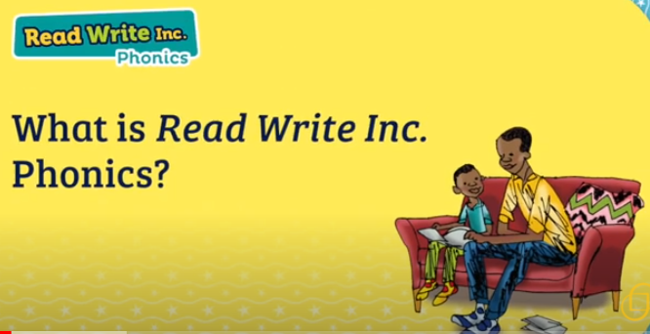
https://www.youtube.com/watch?v=sjlPILhk7bQ
Parent video: What is Read Write Inc Phonics
https://www.youtube.com/watch?v=TkXcabDUg7Q
Information for Parents: How to say the sounds
https://www.youtube.com/watch?v=bXOJUPNVnLc
Parent video: Understanding Phonics

