
All About Me
Name:____________________________________________
Date of birth:_______________________________________

A warm welcome to Claypole Church of England Primary School! At school, we like to find out all about our children. This booklet will help us find out more about your child’s developmental stage, their interests and what motivates them and makes them happy.

We will use this information to help your child to settle in and will help us to plan exciting and appropriate experiences so they can learn and develop to their full potential. There are no right or wrong answers and don’t worry if you are unable to answer them all – just come and ask.

We look forward to discussing your child’s development and progress with you at parent’s evenings and talk to you about how your child has settled in, what they are learning and discovering, how they’re progressing and what you can do to help at home. We look forward to working with you.

Best wishes,
Miss Kurvink Class teacher
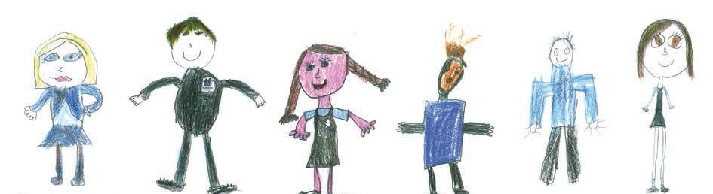

Language(s) spoken at home

Favourite/Special Toy

Favourite stories/book(s)

Favourite songs/rhymes

Interests
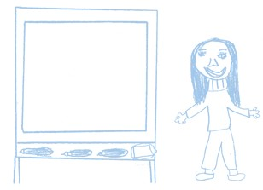

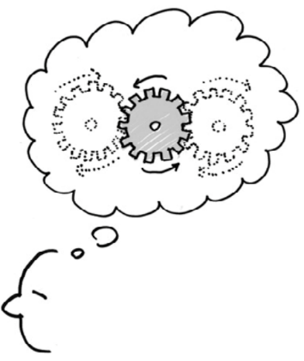
Problem Solving, Reasoning and Numeracy
I can use number words when I’m playing and in songs
For example…

I can sort objects into groups
For example…

I can explore shapes and sizes of things (puzzles, building blocks)
For example…

Knowledge and Understanding of the World
I can explore new things and how they work
For example…

I enjoy exploring how mechanical and IT works (electronic toys, computer, camera…)
For example…

I can talk about special people or events in my life
For example…

Physical Development
I can move around in a range of ways (jumping, climbing…)
For example…

I am beginning to manage my own toileting and handwashing
For example…

I am showing increasing control using my hands and fingers to do things (zips, drawing, feeding, buttons…)

Creative Development
I can show an interest in colours and recognise the difference between them. For example…

I enjoy imaginative play
For example…
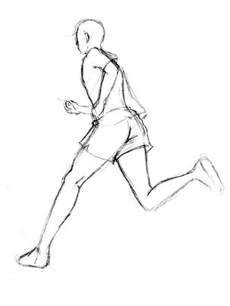
I join in with songs and music-making
For example…

Family and important people in your child’s life
(siblings, grandparents, aunties/uncles, close friends…)

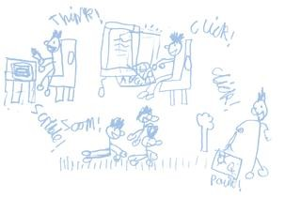
Significant friends at school or outside of school

Medical issues and/or allergies

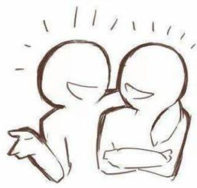
Personal, Social and Emotional Development
I am confident to try new things
For example…

I can make choices and likes to do some things by myself
For example….

I respond well to encouragement
For example…

Communication, Language and Literacy
I can show and tell you what I’m thinking and doing
For example…

I enjoy music, rhymes, songs and stories
For example…

I can make marks with different things (chalk, crayon, paint…)
For example…

Share with us any concerns or worries you may have:

Any additional information we may need to know:

In the Reception Year, the curriculum is planned and resourced to take children’s learning forward and to provide opportunities for all children to succeed in an atmosphere of care and of feeling valued. The curriculum for the Foundation Stage is designed to ignite children’s curiosity and enthusiasm for learning, and to build their capacity to learn, form relationships and thrive. The curriculum is planned in seven areas of learning and development; all areas are important and inter-connected.
There are three prime areas which are:
• Communication and Language Development involves giving children opportunities to experience a rich language environment; to develop their confidence and skills in expressing themselves; and to speak and listen in a range of situations.

• Physical Development involves providing opportunities for young children to be active and interactive; and to develop their co-ordination, control, and movement. Children must also be helped to understand the importance of physical activity, and to make healthy choices in relation to food.

• Personal, Social and Emotional Development involves helping children to develop a positive sense of themselves, and others; to form positive relationships and develop respect for others; to develop social skills and learn how to manage their feelings; to understand appropriate behaviour in groups; and to have confidence in their own abilities.

There are four specific areas through which the three prime areas are strengthened and applied. These specific areas are:

• Literacy Development involves encouraging children to link sounds and letters and to begin to read and write. Children must be given access to a wide range of reading materials (books, poems, and other written materials) to ignite their interest.

• Mathematics involves providing children with opportunities to develop and improve their skills in counting, understanding and using numbers, calculating simple addition and subtraction problems; and to describe shapes, spaces, and measures.

• Understanding the World involves guiding children to make sense of their physical world and their community through opportunities to explore, observe and find out about people, places, technology and the environment.

• Expressive Arts and Design involves enabling children to explore and play with a wide range of media and materials, as well as providing opportunities and encouragement for sharing their thoughts, ideas and feelings throu gh a variety of activities in art, music, movement, dance, role- play, and design and technolo

