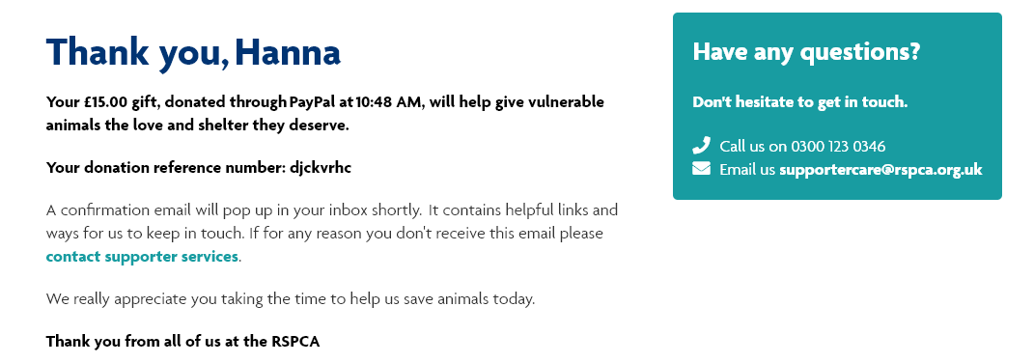

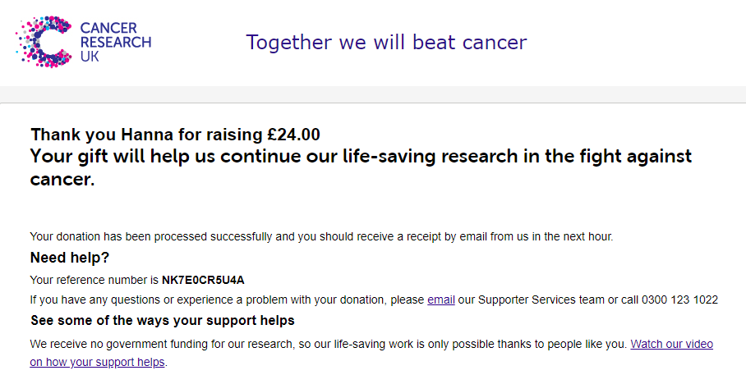

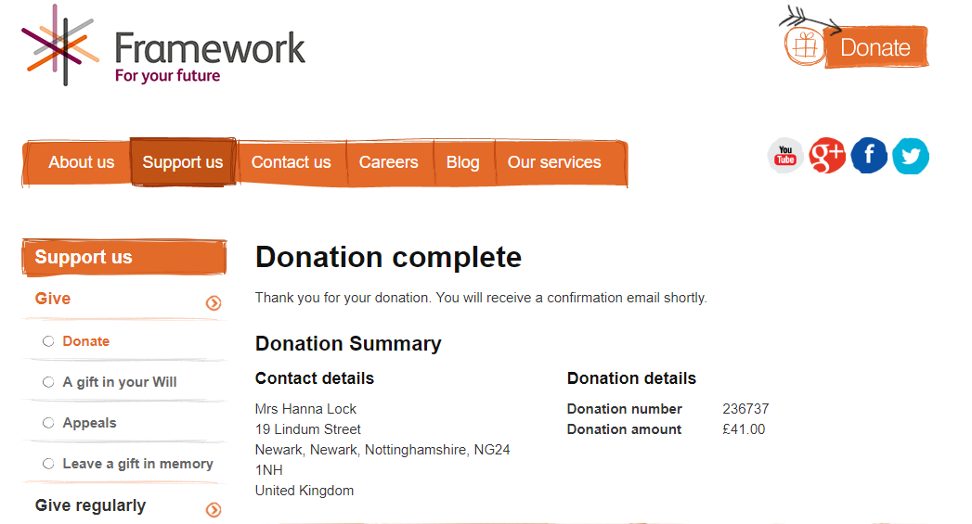
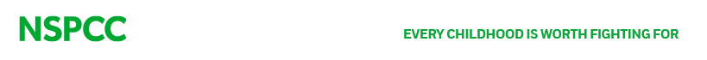
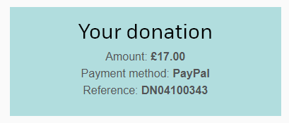
Well done 2019 Y6 Leavers…you raised an amazing £97 for charity and an incredible £91 for school funds. What a legacy to leave behind in your final week of Primary! All from a £5 note…you are great entrepreneurs! Thank you to everyone for your support.

